Oceania-PAC-POLY-Nukuoro-Outrigger

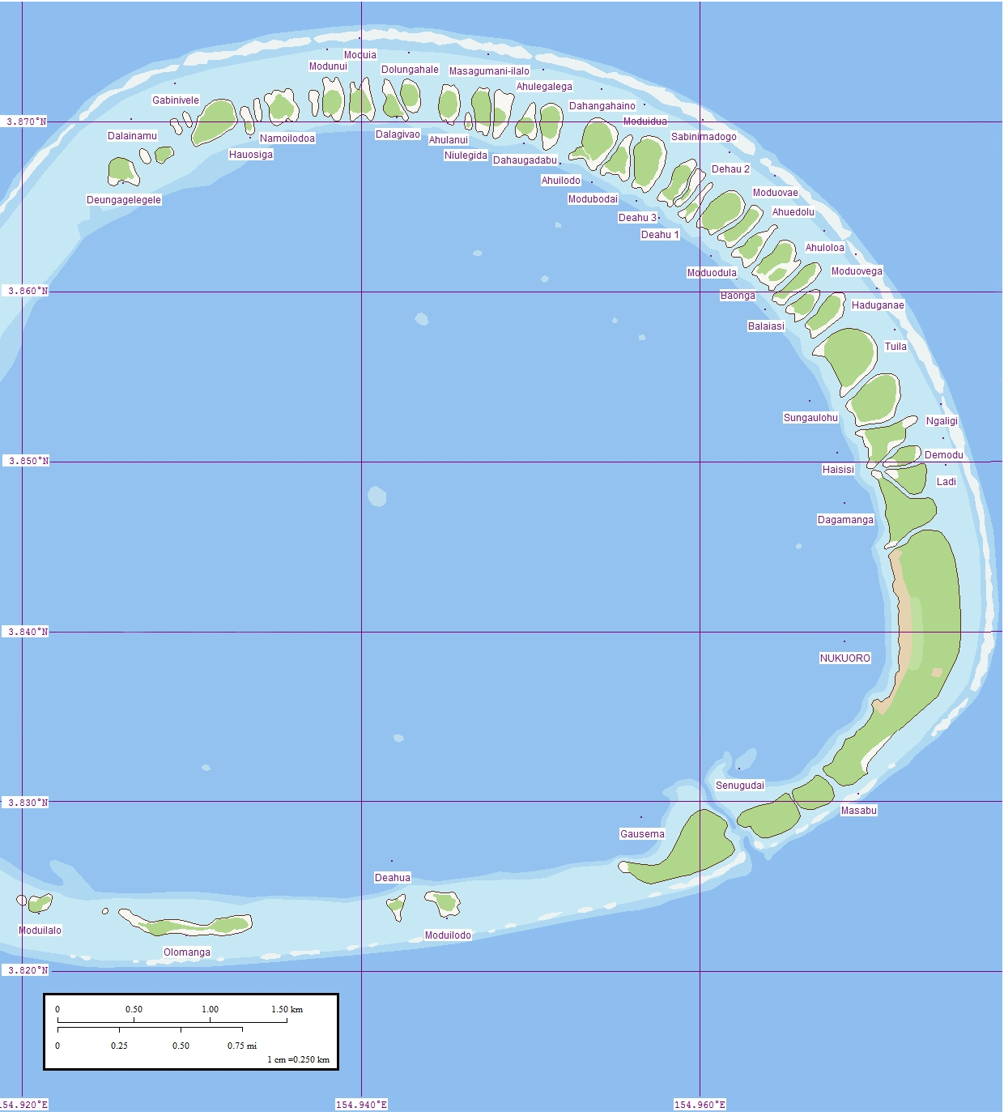

Fig. 1. Nukuoro Atoll, Caroline Islands, Micronesia. Map of eastern rim that contains forty-six small islets or *modu*.

Nukuoro’s Polynesian Background and Their Tuvalu Style Outrigger

Nukuoro Atoll (Ponape District, Trust Territory of the Pacific Islands) is a nearly circular atoll with a deep central lagoon and a fringing reef with forty-six small islets or *modu* (cf. Hawai’ian *motu*) that extend from the northwest clockwise to the southwest, which at low tide are interconnected.

Nukuoro atoll was settled in the eighth century AD/CE, by Samoan migrants who voyaged in two canoes under chief Wawe, landed at Nukufetau in Tuvalu and then set sail for the uninhabited *modu* of Nukuoro atoll in Micronesia. The settlement of a Micronesian atoll by Polynesians created a “Polynesian outlier”. The eighth century is important climatologically and socially, since favorable weather conditions during the seventh century had induced increasing populations on many Pacific islands making the incentive to migrate attractive to many as internecine strife ensued with the stresses of increasing populations. These Nukuoro immigrants brought their Polynesian language, concepts of social hierarchy, genealogy, and an aesthetic acumen that would inform the basis of a totally unique style of human figuration in banana-fruit wood as in the current example. In addition, these Polynesians also incorporated Micronesian principles from Tuvalu such as outrigger canoe construction that was useful in an isolated atoll (as in the current outrigger canoe model) and banana-fiber loom weaving which proved suitable for canoe sails (as in the current outrigger canoe model) as well as clothing for themselves and for adorning figures of their deities.

Nukuoro was first contacted by western Europeans when the Spanish Captain Juan Bautista Monteverde of the frigate Pala on 18 February 1806 en route from Manila to Lima, Peru named Nukuoro "Dunkin Is." and noted that the natives who came out to trade "are of the most pacific disposition" (Hezel 1979, Sharp 1960: 189, Ward 1967).

## References

## De Grunne, B. 1994. “Beauty in Abstraction: the Barbier-Mueller Nukuoro Statue”. *Art Tribal*, Geneva: 25-40.

## Doane, E.T. 1874. The Caroline Islands (Cruise of the Star). The *Geographical Magazi*ne, 1:203-205.

## D’Urville , M.J. Dumont. 1843. *Voyage au Pole Sud et dans L’Oceanie sur les Corvettes L’Astrolabe et la Zelee*. Vol. V. Paris, Gide et Cie.

## Eilers, A. 1934. “Inseln um Ponape”. *Ergebnisse der Sudsee-Expedition 1908–1910*. IIB Vol. 8. Hamburg, Friederichsen de Gruyter.

## Hezel, Fr. Francis X. S.J. 1979. http://www.micsem.org/pubs/articles/historical/forships/pohnpei.htm .

Kaeppler, Adrienne L. 2008. The Pacific Arts of Polynesia & Micronesia .Oxford: Oxford University Press.

Kaufmann, Christian, Oliver Wick (eds.). 2013. Nukuoro. Sculptures from Micronesia. Basel: Fondation Beyeler, Hirmer.

## Kubary, J. 1900. “Beitrag sur Kenntnis der Nukuoro- oder Monteverde Inseln”. *Mitteilungen der Geographischen Gesellschaft in Hamburg*, XVI.

## Morrell, Benjamin. 1832. **A Narrative of Four Voyages to the South Sea, North and South Pacific " Ocean, Chinese Sea, Ethiopic and Southern At/antic Ocean, Indian and Antarctic Ocean, from the Year 1822 to 1831**. New York, J. & J. Harper.

Sharp, Andrew. 1960: The Discovery of the Pacific Islands. Oxford: Clarendon Press.

## Volprecht, K. 1968. “Nukuoro: Zur Sammlung Kapitan Jesche im Rautenstrauch-Joest-Museum.” *Ethnologica* (NF) Band 4: 532-542.

Ward, R. Gerard, ed. 1967. American Activities in the Central Pacific 1790-1870.8 Vols. Ridgewood, NJ, The Gregg Press.